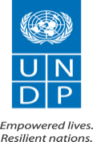
UNITED NATIONS DEVELOPMENT PROGRAMME

FUTURE READY
SCALE-UP

PROMOTING SKILLS & LIVELIHOOD IN THE DIGITAL ECONOMY

Program Document

DRAFT 1.0
15 MARCH 2021

Project Title:
Project Number:
Implementing Partner:
Start Date: End Date: PAC Meeting date:
Brief Description
Briefly describe the overall development challenge and the expected results of the project.

Contributing Outcome (UNDAF/CPD, RPD or GPD):

Indicative Output(s) with gender marker²:
Total resources required:
Total resources allocated:
UNDP TRAC:
Donor:
Government:
In-Kind:
Unfunded:
Agreed by (signatures):
Government | UNDP | Implementing Partner
Print Name: | Print Name: | Print Name:
Date: | Date: | Date:

Table of Contents
1. Background and context 4
2. Change path- Towards more inclusive digital economy 9
2.1. Scaling up- based on lessons learned 9
2.2. Theory of change 13
2.3. Programme linkage to National Priorities and International Frameworks 17
3. Results and Partnerships 21
3.1. Expected Results 21
3.2. Pre-launch activities/ongoing activities 26
3.3. Partnerships and Ecosystem Engagement 26
3.4. Targeted beneficiaries 27
3.5. Geographic scope/ target locations 28
3.6. Risks, Assumptions and mitigation strategies 28
3.7. South-South and triangular cooperation (SSC/TrC) 29
3.8. Knowledge, Communications and Visibility 30
3.9. Sustainability 30
4. Results Framework 31
5. Monitoring and Evaluation 35
6. Governance and Management Arrangements 37
6.1. Governance structure 37
6.2. Management ARRANGEMENTS (Adaptive and agile approach) 38
7. Multi-Year Work Plan (Tentative) 40

Background and context
The global digitalization of the social, public and private sectors and economies, often characterized as the ‘fourth industrial revolution’, is rapidly disrupting labour markets. There is not a single element in society that is not influenced by the digitalization. Risks associated with “missing the boat” are high. Opportunity to introduce services and products that would have been impossible in the ‘traditional’ economy are promising. However, the technology adoption often causes short-term labour displacement. As the costs of machinery and other technologies continue to lower, workers in low-skill, routine-intensive jobs are affected by automation.
The World Economic Forum´s Future of Jobs Report 2020, now in its third edition, tracks profound changes in digital economy, and maps jobs and skills of the future. The research is tracking the pace of change based on surveys of business leaders and human resource strategists from around the world. Traditional jobs will disappear, and new ones will emerge. In the most recent years, the emergence of technologies such as artificial Intelligence, robotics, web programming and mobile app development has transformed the typology of digital jobs and expanded the demand for people across different skill levels. Rapid advances in these emerging technologies are happening in a short cycle, which is changing the very nature of jobs and is widening the skills gap. The report also sheds light on the effect of COVID-related disruptions placed in the broader context of longer-term technology trends. It comes at a crucial juncture for the world of work.
The digital revolution has significant implications on traditional ways of addressing job security and social protection for many workers globally. Many new forms of work in the digital economy, defined broadly as a gig economy, offer advantages such as flexibility in terms of hours and the ability to work from remote locations. At the same time, this work can be viewed as precarious, offering little or no job security, and thus comes with its own challenges and requires responsive design, if gig economy concept is to be used in global poverty reduction.
Technology proliferation, openness of business to remote work, and global pay-scale differences create powerful opportunities for outsourcing, freelancing and global digital economy links to many countries. The key element behind the digital economy is that it is capable of opening up for opportunities regardless of physical, social and economic barriers typically existing between youth and the decent jobs.
In Somalia, despite significant improvements in the past few years, most citizens still live in a difficult situation with high levels of poverty, insecurity and vulnerability to disasters. Being a post-conflict country, that is undergoing stabilization through a state-building enterprise, the ability to work uniformly around the issues of humanitarian, development and peacebuilding agendas is challenged.
Digital infrastructure is increasingly improving in Somalia after the Civil war, aiming to catch up with the rest of the world. The internet penetration remains low, at 11.9% in January 2020, but is steadily increasing at 7.4%. Further, it is expected to significantly improve upon completion of projects on connectivity through additional fibre optic cables and last mile cable with neighbouring countries.
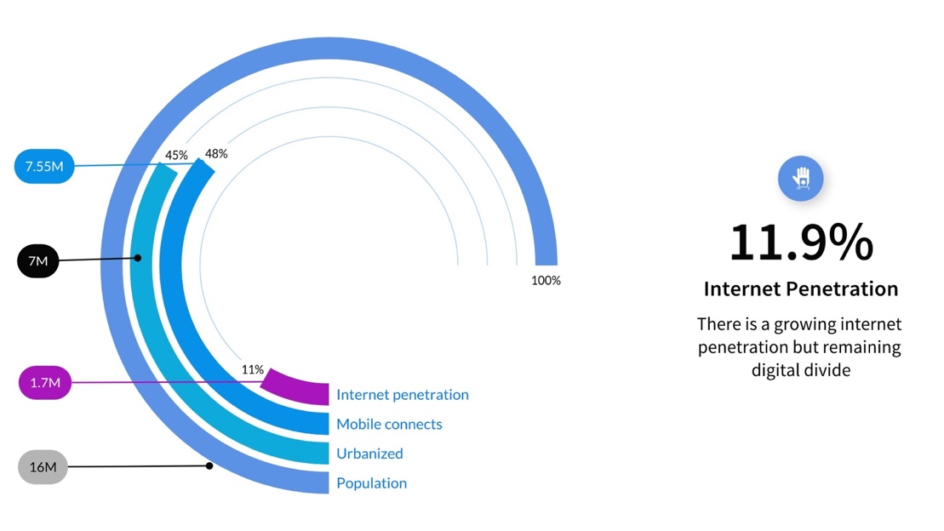
Schema 1. Internet penetration by groups in Somalia
Somalia National Development Plan (NDP9) explicitly calls for “sustainable, inclusive growth and economic diversification” with emphasis on the digital economy. The traditional economic sectors in Somalia are not sufficient to provide the desired GDP growth. As a response to NDP9, the UN Cooperation Framework support plans for “economic diversification, resilient productive sectors, labour market need and supply alignment” to advance sustainable development agenda in the country. There is an alignment for accelerating the growth of service economy sector, based on digital technologies and skills, in addition to a digital transformation of traditional investment sectors in Somalia.
The private sector in Somalia has survived the tumultuous period and has a growing interest in the digital economy. Somali businessmen and women continue to innovate and adapt in the absence of a strong functioning government. Investments from multilateral institutions, such as the World Bank Group, are targeted to strengthen the private sector, focusing specifically on energy, ICT, transport, telecom and financial sector industries. The telecommunication and banking sectors have been the major demanders for digital work in the country and remain the most lucrative employers in the digital economy. Seven out of ten Somalis use their mobile devices regularly to access mobile payment services, with over 150 million transactions a month, worth $2.7 billion or 36% of GDP. Due to the persistent instability and security issues, few multinational corporations are present in Somalia to be considered employers. However, there is a growth in infrastructure and related investments in transport and digitalization from Gulf States’ and Turkish companies. In parallel, Somali Small and Medium-sized enterprises´(SMEs´) adoption of digital technologies, including creating web presence and mobile apps, is also growing with recent extensive investment in business development and enterprise support.
Informality of the economy affects hiring practices in the digital economy as well. There is a lack of transparency in recruiting by companies in Somalia across large, medium and small enterprises. According to World Bank’s survey of 2019, the majority do not use any digital means for selection and hiring but use personal networks to reach talents.
The Somali innovation and technology ecosystem is steadily growing. Somali innovation hubs, accelerators and incubators engaged in technology, talent and entrepreneurship development have been emerging across the country in the last decade.
These hubs provide access to infrastructure, seed funding and workspace, they engage rising talents and are building robust interest in the digital technologies in the economy. Among the hubs are I-rise hub, IITEE SIMAD, Bilan Codes, Saanqaad, Hanaqaad, Harhub, SOMTAC and T-hub. There hubs were engaged with UNDP through the Future Ready pilot project between 2017 and 2019. Despite this emerging trend, the hubs are still facing severe capacity, funding and sustainability challenges. Because of distrust to many financing institutions, and prevalence of Somali’s entrepreneurship in relying exclusively on personal funds, the growth of technology entrepreneurship is hindered by the lack of funding.
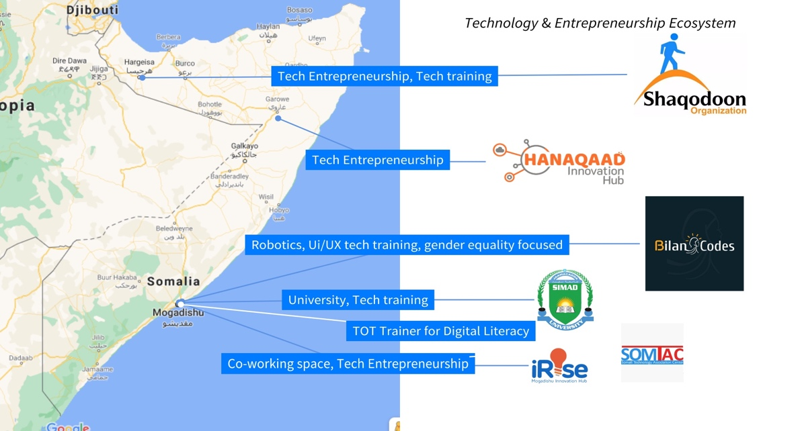
Schema 2. Technology and Entrepreneurship ecosystem in Somalia
Somalia is home to the fourth youngest population in the world. Young people aged under 35 comprise about 75 % of the population. Unemployment rate for youth is at 73 %. High youth unemployment is a threat to stability and security, with male youth likely to be recruited into violent extremist organizations and girls forced into early marriage and experiencing sexual and gender-based violence. However, the large proposition of the country´s population being youth, also presents an opportunity, because young people are usually characterized as more tech-savvy, creative, passionate, dynamic and thus, open to new technologies and working in the digital economy.
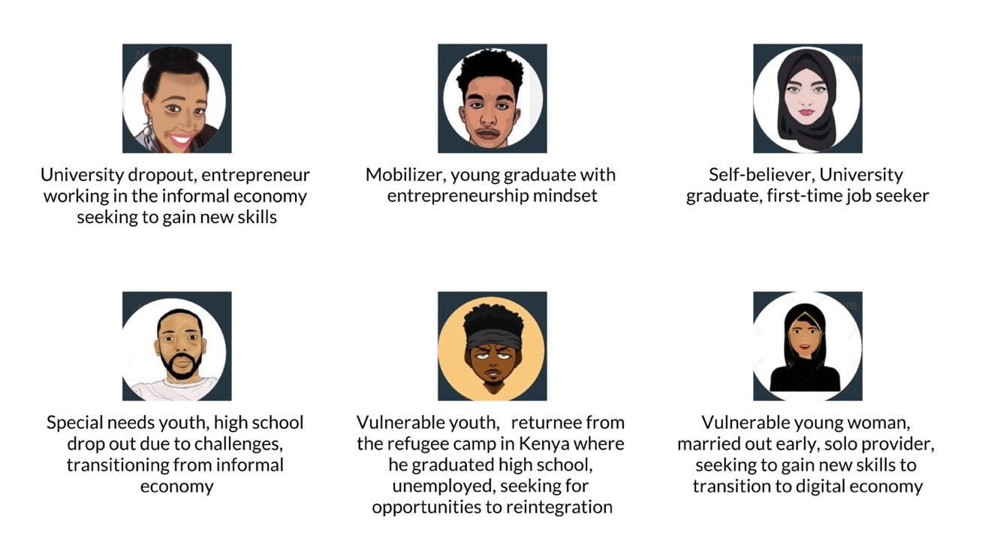
Schema 3. User stories. Ethnographic design for Future Ready Scale-up in Somalia.
Sustainable jobs creation for young men and women is a top national development priority. This has been clearly stated in the National Employment Policy launched in 2019. In the following year the Somali government also organized the first-ever National Employment Conference, calling for further investments in technology and digital skill focused technical vocational education training (TVET); jobs in the digital economy that are not bound by geography; and utilizing online, education models more prominently. The above-mentioned strategies are considered as very likely solution to the youth unemployment challenges facing the country.
The Somali education system do not establish programmes responding to emerging trends for employable skills in the digital economy. TVET focusing on technology and digital skills is ad-hoc based and needs structured support and investment. Local technology and entrepreneurship hubs provide short term standalone training that is often not leading to systemic change.
There is limited data for the market of technologies and digitals skills in demand for Somalia. Neither academic, nor TVET focusing on technology or digital skills are demand-driven, and thus is falling short in connecting new skills to employment & livelihood opportunities in Somalia or international markets.
Without targeting policies, the growth of the digital economy may result in acceleration of the digital divide. Investing in digital skills, and markets, must allow young men and women to access digital livelihood opportunities, regardless of their location and baseline education. There is a risk of certain populations, particularly women, displaced people, returnees and people with disabilities, being left behind if they cannot adequately adapt and develop the new skills. Through adequate targeting, adapted training, and advocacy for employers these groups need to acquire the knowledge and qualifications, and gain equal access to take advantage of the job opportunities offered by the digital transformation.

WOMEN. The gender disparity in the labour market translates to the digital economy. In Somalia, the Gender Inequality Index is alarmingly high, at 0.776 (with 1 denoting the highest inequality) placing Somalia as forth highest position globally. Women suffer more exclusion than men in terms of economic empowerment when it comes to labour market participation. Digital jobs can increase young women’s productivity, earnings, and financial independence. Jobs involving online work offer flexibility that can help young women to overcome mobility constraints and combat restrictive gender norms in Somalia.

DISPLACED PEOPLE/RETURNEES. Somalia is struggling with a displacement crisis, with an estimate of 2.4 million displaced people within the country. In addition, some 877,000 Somali refugees live in neighbouring countries, making them one of the largest refugee population in the world. Forced displacement, drought, closures of the refugee camps in neighbouring countries, and the impact of the COVID-19 pandemic have further exacerbated the displacement situation. There are specific challenges for the returnees and IDPs in Somalia. Majority of the returnees from camps lack marketable skills and work experiences to meet the demands. In addition, diluted personal connections inside the country impact their ability to tap prevalent informal channels of hiring. The typical returnees work experiences, in food preparation and tailoring, are in oversupply, leaving the majority excluded from the tide of the digital economy. Finally, the low literacy rates among the vulnerable groups impact the ability to use online and print media for recruitment or get any office jobs.
PEOPLE WITH DISABILITIES. Somalia has a significant number of people with disabilities, at 4%, facing specific challenges in employment. The high percentage is a result of a long period of conflict, poverty, and lack of access to health care in most of south and central Somalia. Remote flexible digital work will bring opportunities for decent jobs for people with physical disabilities, especially for youth.

When it comes to inequality exclusion, digital economy programmes offer a greater spectrum of jobs than traditional. It allows the individuals with and without computer science degrees to access diverse jobs and has a potential to attend differences and expectations of youth for employment from different backgrounds, social classes, or with certain disabilities. Inclusive digital economy, therefore, offers distinct career paths through, training on foundational digital literacy, to become office staff, professional full stack engineer, data analyst or tech entrepreneur.

Change path- Towards more inclusive digital economy
Somalia is in the process of diversification of its economy after the prolong civil war. As part of the implementation of peace, humanitarian, and sustainable development agendas, UN Cooperation Framework (2021-2025) is focused on building a socio-economic structure that is resilient to shocks; re-integrating Somalia in the global economy; and creating employment that is safe, productive and remunerated equally. Accelerating the growth of the digital economy could contribute significantly to the ambitious SDG goals and has been one of significant priorities for Somali National Development Plan, UN Cooperation Framework and UNDP Country Program Document (2021-2025).

Scaling up- based on lessons learned
The present Program ‘Future Ready – Scale up: Promoting digital skills and livelihoods in the digital economy’ is built on the pilot initiative Future Ready, which was carried out from 2017 to 2019. The pilot was designed in partnership with Microsoft, and with implementation through selected local technology and innovation incubators: Shaqodoon (Harhub) and SOMTAC. Additional sessions in the form of training of trainers (ToT) led to building local capacity and Institutionalizing process and models.
From July 2017 to the end of 2019, the Future Ready pilot engaged total of 257 youth (187 Male-70 Female) directly in 3 Skill Development categories: Computer science and programming; Digital Story (Digital Media) and Digital Literacy for people with Disabilities and IDPs. The top 19 participants went further in an extended Information Technology Institute (ITI) of Egypt´s Scholarship as part of South-South Cooperation. The new Program will build on the initial collaboration between Somalia’s National Technology Institute and ITI Egypt, although other options may need to be explored.
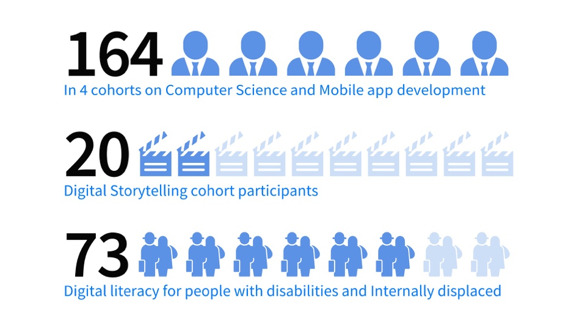
Schema 6. Future Ready Pilot statistics
In 2020, UNDP Somalia conducted an independent assessment of the Pilot project The assessment was carried out in order to demonstrate ‘proof of Concept’ as well as to define the required elements of the scaled-up Digital Economy programme.
While, throughout the development of the present program, the different lessons learned have been integrated, some of the more important lessons learned are outlined in the table below. The digital economy is first of its kind in Somalia, it is important to ensure close alignment and create synergy with other skills development and employment initiatives. This has been fundamental throughout the formulation process and it has become an organizing principle in the proposed program.

Guiding Principle | Lesson learned for proof of concept | Application in the Scale-up Programme
Ecosystem approach | Somalia is a complex and fragile environment. The pilot programme used elements of an ecosystem approach: where various actors contribute to the design and implementation of activities. | The scale-up will focus on strengthening the ecosystem with emphasis on consultation, co-design and collaboration with actors (government agencies, academia, technology and innovation hubs, private sector, and international actors).
Government-led, local actors’ driven process to institutionalize business model, and tools for sustainability and resilience proposes | In the pilot phpase, UNDP was in direct implementation, with training conducted with support of Microsoft and low practical component, and high teach to student ratio. Greater scalability is seen through combination of designing processes, frameworks, and uniform curriculum, but implemented, delivered and driven by the Government and local actors through ToT. | For the new design, UNDP conducted a series of co-designs and consultations with local technology and innovation hubs, academia, and the Government (Ministry of Labour and Social Affairs and Ministry of Information and Telecommunication). The shared vision is to build locally institutionalized models, processes and framework easily scalable across Somalia, and with Government at the ownership for sustainability.
Diversification of digital training and jobs typology | The pilot has demonstrated a need in creating diverse career paths and adapting training curriculum according to broader digital jobs typology and market-demand to attend to differences in education levels; desired work arrangements; and limitation imposed by Somali economy and access to the global markets. | The new programme will categorize training program in different level: basic, intermediate and advanced stages, as well as it will allow to move from one-off engagement on upskilling university graduates to the continuous career development for youth from all baseline levels of education to employment. The training will be modelled based on the future functional career tracks: software engineer, designer, data analyst, multi-media or digital marketing analyst, and other digital jobs need in the local market. In addition, the programme will incorporate distinct tracks for livelihood: waged employment, freelancing and entrepreneurship. A soft skills training component will be designed based on combination of functional and livelihood tracks.
Addressing both demand & supply side in the digital economy | In the pilot experiment, the focus was on skills development (supply side and not on the demand side). Providing training programs on digital skills may be insufficient to stimulate youth employment in the context of private sector development challenges or if potential employers remain disengaged. | The new programme will focus on the drivers of demand for digital jobs, as well as the supply of available skills to perform those jobs, by assessing market demand for digital skills. The rigorous private sector mapping and engagement is required for a full map of digital jobs demand in the country, as well as assessing market gaps for digital jobs internationally and formulating an opportunity for Somalia in the global digital economy.
Digital inclusion of women and the most vulnerable people (people with disabilities, IDPs & returnees), Leaving No One Behind (LNOB). | The pilot trainings included IDPs, returnees and people with disabilities (PwD). Efforts were also made in order to include a high proposition of women in the trainings, however, the participation of women remained low, at 15%. The assessment demonstrated the clear need in logistical, language and structural barriers to ensure digital inclusion of young women and other vulnerable groups. | The new programme design will avoid ‘digital-divide’ by targeting individuals with and without computer science degrees, and attend differences and expectations of different groups, including IDPs, returnees, and PWDs. A digital inclusivity strategy will be developed to guide the programme implementation.
Private sector engagement | The pilot programme had limited but promising engagement of private sector companies, mainly Somali banks and Telecommunication companies. However, further engagement of employers is necessary to build a trust and continuous demand for talent. There is a proven opportunity in Somali private sector-led employment for youth, in particular in the growing service sectors: Banking, telecommunication, energy, manufacturing and retail/e-commerce, as well as through enterprise support service rendered to SMEs. | Initial thorough and systematic engagement with Somali private sector is required in the programme design through mapping demand, as employment partners as well as through digital platform for recruitment transparency. In addition, exposure to international hiring through direct engagement with technology companies or agencies will bring additional jobs to freelance engineers or data analysts from Somalia.
Fostering digital entrepreneurship with technology incubation, enterprise, Business development support and access to finance to fill existing market gaps | Growth of entrepreneurship is a high national priority. It can reduce reliance on the challenging Somali economy and significantly contribute to youth employment. From the Future Ready pilot experiences, Somali youth possess ideas and greatly understand the market gaps and opportunities for ideation of technology products. However, there was a high share of failure by tech start-ups, mainly because of lack of access to finance, and enterprise support to build capacity to grow ideas into commercially viable enterprises. | Digital or tech entrepreneurship is considered one of the pathways for sustainable employment alongside waged employment and freelancing. To facilitate the creation of commercially viable enterprises using technology product, UNDP will work on capacity building of local hubs not only to incubate ideas, but further facilitate the access to seed funding, support in business registration of enterprises, and commercialization of technology products into viable business models in Somalia. In addition, UNDP will work with diaspora-operated companies globally to support the scale ups of innovative technology solutions born in Somalia in the global markets.
Digital economy platform for increased transparency of supply demand | The pilot programme assessment discovered the challenges in following up with programme alumni as job seekers, mentors or entrepreneurs. As a result, many participants failed to land the relevant jobs. | In the new programme, UNDP will ensure data-driven approach and creation of community for skills-job matching and forecasting demands. Building a digital platform is seen as a way to bring the alignment between training and employment. In addition, the digital platform is an effort to bring more transparency to the informal and personal network-based recruiting practices of the private sector. This will allow companies to effectively influence the digital skills training curriculum and it will contribute to process of incorporating project-based training through internship and early work experiences for the trainees, to fill the talent gaps in digital skills.
Building Network  (National, Regional and Global) | UNDP has facilitated South-South cooperation between the Somali Government, local technology and innovation hubs, and partnering Government institutions in Egypt and Bangladesh. These experiences demonstrated a potential to further explore the exchange programmes, connecting with international technology partners, or Government programmes. | The new programme will build on the cooperation experiences for advanced student exchange. UNDP will also aim to form an agency-driven employment for Somali youth through partnerships with the software engineering service providers and/or global technology employers.
Table 1 Summary of Assessment of Future Ready Pilot. Lessons learned that will serve as a building block.

Theory of change
The traditional linear theory of change outlines how planned activities must be undertaken to reach the desired strategic impact, allowing each activity to lay the foundation for the next as a chain of actions. However, a linear approach may work better in a well-known and predictable environment. In the context of Somalia and the complexity related to an evolving nature of digital technology, there is a need for a flexible and agile environment, where ecosystem stakeholders dynamically plan and contribute to the challenge, adapt solution design and implementation steps.
UNDP will adapt ecosystem approach, which are more applicable in a complex and evolving environment like Somalia. The ecosystem approach put system-thinking at the centre, emphasizes on engagement, on collaboration, on participation, on inclusion and flexible response. The approach focuses on adaptation, iteration, learning process, smart risk-taking, scaling-up the successful and dropping the failures as the programme progresses. Systems thinking allows to see the challenge as interconnected process. In the context of Somalia’s digital economy challenge, it is at the intersection of integrated skills development, employment and livelihood interventions and private sector engagement in the context of protracted & post conflict-setting.

1.Enhanced capacities of the government and local technology hubs to design and implement inclusive, integrated digital skill development for market-driven digital jobs (Supply-side components)

Reduced Poverty and Inequality in Somalia
Employment and Livelihood creation in the digital economy, contributing the growth of service sector in the GDP (target of 2% increase)

There is high level of poverty, inequality and youth unemployment in Somalia and disconnect in supply of talent and market demand in the digital economy

2.Strengthened mechanisms, partnerships and platforms for employment and livelihood & job creation in the digital market

3.Improved Institutional frameworks to support digital economy (System level consideration)

Strengthening the Ecosystem and capacity in the digital economy

Schema 8. Theory of change for Future Ready Scale-up
Challenge: There is a high level of poverty, inequality and youth unemployment in Somalia, resulting from persistent disbalance in the supply of talents and demand in the market of the digital economy.

If,
- Somali young men and women, including displacement affected communities and people with disabilities, at all education levels, are able to gain new, diverse and certified digital skills to participate meaningfully in the digital economy,
- The digital skills training design reflects on the drivers of demand for digital jobs, as well as leverages existing talent’s advantages through private sector mapping and job forecasting,
- The capacity of government and local technology and innovation hubs in driving digital economy programme is strengthened,
- The programme integrates digital skills training with soft skills for careers or enterprise development,
- Private sector employers, in a transparent way, are interested in recruiting graduates through internships and capstone programs, followed by formal employments in the national digital economy,
- There is mentorship, funding and an infrastructure, in place for emerging tech entrepreneurship ideas,
- Institutional framework is developed,
- There is south-south cooperation, global linkages, and networks in place.
Then,
- Return on investment in digital skills training is increased,
- The graduates of programme are placed in sustainable waged employment in Somalia that will reduce high level unemployment
- The graduates open new employment opportunities through cross-border freelancing platforms and agencies,
- The graduates develop commercially viable entrepreneurship models for self-employment,
- There is a data-driven approach through platform connecting real-time and forecast of supply and demand, training providers with employers,
- The demand for matching skills among Somali’s private sector is filled with a high caliber cadre and talent,
- A favourable enabling environment is created for diversifying Somalia’s economy towards digital.
Resulting in,
- Young Somali men and women, including displacement affected communities and people with disabilities, will have an increased opportunity for equal employment and livelihoods in the digital economy, contributing to the increase of service sector contribution to GDP, targeted at an 2% annual increase.
The immediate outcomes are:
- Enhanced capacities of the Government and local technology and innovation hubs to design and implement inclusive, diversified digital skills development
(Supply-side component)
- Strengthened mechanisms, partnerships and platforms for employment and livelihood & job creation in the digital market (Demand-side components)
- Improved institutional frameworks to support digital economy (Systemic and institutional change)

Strategic outcome 1: Enhanced capacities of the Government and local technology and innovation hubs to design and implement inclusive, digital skills development for market-driven digital jobs (supply-side component)
Output 1.1: Ecosystem readiness. Understanding of the national digital economy ecosystem, related processes and data flows, capacity assessment of local technology and innovation hubs. |  | Output 1.2: Targeting. Mechanisms and incentives set for recruiting beneficiaries, including targeting vulnerable groups of people with disabilities, IDPs and returnees. | Output 1.3: Training and curriculum design. Digital skills trainings are organized to produce certified digital talent, having options for different employment paths |  |  | Output 1.4: National capacity building for implementation. Technical knowledge of the Government and local technology and innovation hubs is enhanced to institutionalize tools and models as formal TVET for digital economy.
Strategic outcome 2: Strengthened mechanisms, partnerships and platforms for employment and livelihood & job creation in the digital market (demand-side component)
Output 2.1: Market demand Assessment. Private sector market demand mapping for digital skills at national levels including specific analysis to understand the gender dynamics within the Somali digital labour market. | Output 2.2: Employability and Job placement. Mechanisms to connect graduates to digital jobs through internship or capstone placements, talent festivals, demo days, access to platforms for freelancing, and microwork. |  | Output 2.3: Digital Economy Platform. A data-driven platform for connecting real-time and forecast of demand-supply in the digital economy. The platform will connect the digital workforce with employers, aggregate job sites, supply digital skills training hubs and policy makers with data on supply-demand and allow for additional intelligence and analytics. |  | Output 2.4: Digital entrepreneurship & enterprise development. Design the process to support incubation and commercialization of tech enterprises as a sustainable employment path. This includes enterprise support for commercially viable products, access to finance, access to markets through partnerships with diaspora-led enterprises and global technology companies.
Strategic outcome 3: Improved policy and institutional frameworks to support digital economy (systemic and institutional change)
Output 3.1: Enabling environment. Strategies, policies, quality assurance frameworks and standards and business regulations related to digital economy are in place. |  | Output 3.2: National Technology & Telecommunication Institute. Capacity & infrastructure including Strategic plan, staffing & effective governance and management systems and operating facilities for the institute |  | Output 3.3: South-South cooperation. Partnerships, and processes are in place for south-south cooperation, cross-border employment: certifications, online platforms, software development agencies.
Table 2. Outcomes and outputs of Future Ready Scale-up

Programme linkage to National Priorities and International Frameworks

The proposed programme is fully aligned with Somalia National Development Plan # 9, national policies on youth, employment and ICT as UN Cooperation Framework for Somalia (2021-2025), UNDP Program document (2021-2025), SDGs and Global Refugee pledge.
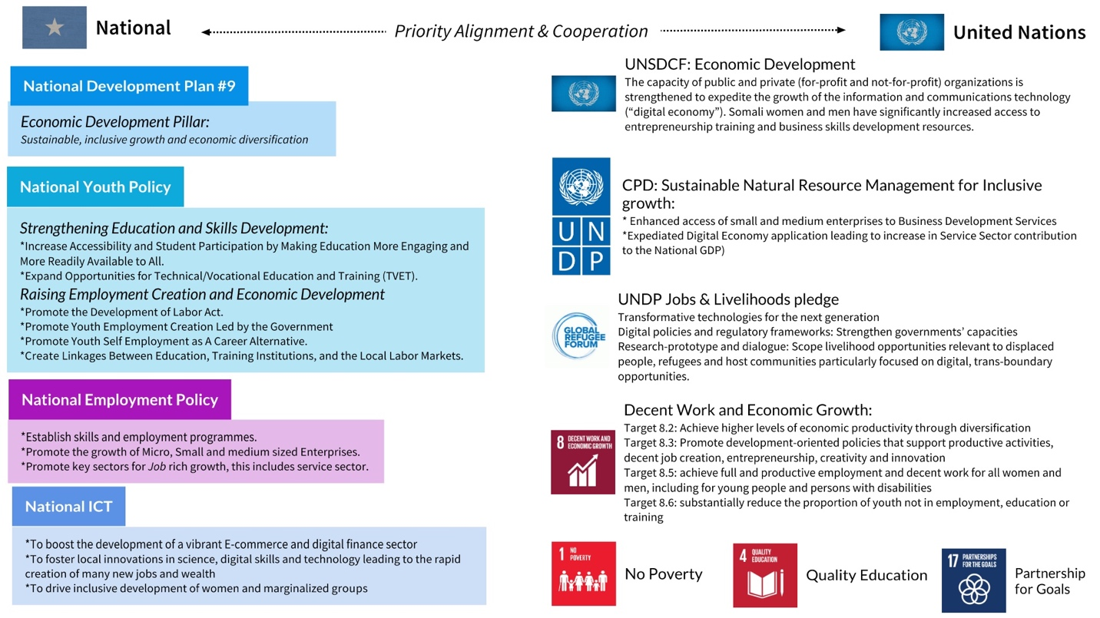
Schema 9. Summary of National, Global and UN priorities and pledges in alignment to deliver on the Digital Economy in Somalia
Somalia National Development Plan #9
The Scale-up programme aligns with Somalia National Development Plan 2020 to 2024 (NDP 9). Specifically, the Economic Development Pillar of the National Development priority calls for “sustainable, inclusive growth and economic diversification”, investing not only in traditional economy sectors but also service and digital-based emerging economy.

The National Youth Policy of the Federal Government of Somalia
The National Youth Policy of the Federal Government of Somalia, launched in 2017, sets vision and priorities of improving lives of Somali youth below the age of 35, who makes up 75% of the population in 2020. The scale-up programme targets the following priority areas in the National Youth Policy:
- Priority Area 1: Strengthening Education and Skills Development
  - Strategic Objective 1: Increase Accessibility and Student Participation by Making Education More Engaging and More Readily Available to All.
  - Strategic objective 3: Expand Opportunities for Technical/Vocational Education and Training (TVET).
- Priority Area 2: Raising Employment Creation and Economic Development
  - Strategic objective 2: Promote Youth Employment Creation Led by the Government
  - Strategic objective 3: Promote Youth Self Employment as A Career Alternative.
  - Strategic objective 4: Create Linkages Between Education, Training Institutions, and the Local Labour Markets.
Even though the National Youth Policy is covering all Somali youth, it recognizes that there are certain groups who require additional emphasis to ensure maximum benefits from the interventions, this includes people with disabilities, IDPs and returnees.
National Employment Policy
The scale-up programme particularly contributes to the following objectives set in the National Employment Policy:
- Objective 1: Establish skills and employment programmes.
- Objective 2: Promote the growth of Micro, Small and medium sized Enterprises.
- Objective 3: Promote key sectors for Job rich growth, this includes service sector.
National ICT Policy and Strategy
The scale-up programme contributes to the following key action points in the National ICT Policy and Strategy (2019-2024)
- To boost the development of a vibrant E-commerce and digital finance sector
- To foster local innovations in science, digital skills and technology leading to the rapid creation of many new jobs and wealth
- To drive inclusive development of women and marginalized groups
- To facilitate the increased role of women, youth and persons with disabilities in ICT.
UN Sustainable Development Cooperation Framework for Somalia
The Scale up programme directly contributes to the following outcomes and outputs in the UN Sustainable Development Cooperation Framework for Somalia:
Strategic Priority 3: Economic Development
- Outcome 3.2: Natural resources are sustainably managed and binding constraints addressed in key productive sector value chains, leading to enduring productivity gains, increased value addition, and enhanced opportunities for decent work.
  - Output 3.2.4: The capacity of public and private (for-profit and not-for-profit) organizations is strengthened to expedite the growth of the information and communications technology (“digital economy”).
- Outcome 3.3: An integrated national programme for human capital development is established, increasing access to market-based skills for all – including the most marginalized and vulnerable groups – and safeguarding their rights.
  - Output 3.3.3: Somali women and men have significantly increased access to entrepreneurship training and business skills development resources.
UNDP Country Programme Document (CPD 2021-2025)
The Scale up programme falls under the Outcome 3 of the UNDP CPD (2021-2025): Sustainable Natural Resource Management for Inclusive growth:
- Output 3.2: Enhanced access of small and medium enterprises to Business Development Services
- Output 3.5: Expediated Digital Economy application leading to increase in Service Sector contribution to the National GDP)
UNDP’s Jobs and Livelihood Pledge
At the Global Refugee Forum, UNDP has announced its co-sponsorship of the digital jobs and livelihoods initiative. Based on the principle underpinning the SDGs to “Leave No One Behind”, this initiative is designed to provide the skills, knowledge and qualifications of refugees and host communities in over 20 countries, including Somalia, to build tomorrow’s skills today. In particular, UNDP will coordinate innovative digital initiatives that foster the economic inclusion of refugees - and support their self-reliance.
The Scale up programme is directly contributing to the following focus areas:
- Focus Area 1: Transformative technologies for the next generation:
- Focus Area 2: Digital policies and regulatory frameworks: Strengthen governments’ capacities
- Focus Area 4: Research-prototype and dialogue: Scope livelihood opportunities relevant to displaced people, refugees and host communities particularly focused on digital, trans-boundary opportunities.
The Sustainable Development Goals
The project directly contributes to the following Sustainable Development Goals (SDGs) and targets:
SDG 1: No Poverty
- Target 1.4: Equal rights to economic resources, as well as access to basic services, ownership and control over land and other forms of property, inheritance, natural resources, appropriate new technology and financial services, including microfinance.
SDG 4: Quality Education
- Target 4.4: Substantially increase the number of youth and adults who have relevant skills, including technical and vocational skills, for employment, decent jobs and entrepreneurship.
SDG 8: Decent Work and Economic Growth
- Target 8.2: Achieve higher levels of economic productivity through diversification, technological upgrading and innovation, including through a focus on high value added and labour-intensive sectors.
- Target 8.3: Promote development-oriented policies that support productive activities, decent job creation, entrepreneurship, creativity and innovation, and encourage the formalization and growth of micro-, small- and medium-sized enterprises, including through access to financial services.
- Target 8.5: achieve full and productive employment and decent work for all women and men, including for young people and persons with disabilities, and equal pay for work of equal value.
- Target 8.6: substantially reduce the proportion of youth not in employment, education or training
SDG 17: Partnership for the Goals
Target 17.6: Enhance North-South, South-South and triangular regional and international cooperation on and access to science, technology and innovation and enhance knowledge sharing on mutually agreed terms, including through improved coordination among existing mechanisms, in particular at the United Nations level, and through a global technology facilitation mechanism.

Results and Partnerships

Expected Results
To help achieve its intended impact, the Program will be implemented through the following three interrelated Strategic Outcome and results to be achieved:
Strategic outcome #1: Enhanced capacities of the Government and local technology and innovation hubs to design and implement inclusive, digital skills development (supply-side component)
Output 1.1: Ecosystem readiness. Understanding of the national digital economy ecosystem, related processes and data flows, capacity assessment of local technology and innovation hubs.
The planned activities include:
- Conducting programme baseline data collection to inform the design of the scale-up
- Consultation processes, involving government, Somali tech & innovation hubs, accelerators and institutes to formulate digital economy priorities
- Broader analysis of the digital economy ecosystem to better understand the roles and processes of digital economy at national, regional and global levels
- Mapping of digital skills demand, digital job typology design, in the national, regional and global markets
- Studying regional and global best-practice models of digital skills training and livelihood creation in post- conflict settings
- Institutional readiness: mapping & capacity assessment of technology and innovation hubs
Output 1.2: Targeting. Mechanisms and incentives set for recruiting beneficiaries, including targeting vulnerable groups of people with disabilities, IDPs and returnees.
The planned activities include:
- Conducting outreach and engagement (both online and offline) activities to attract target groups as beneficiaries.
- Registering, ensuring key eligibility criteria of the programme’s target groups/ beneficiaries.
- Profiling the youth beneficiaries, and collecting baseline data on employment, potential career paths.
- Putting in place the tight monitoring system to evaluate performance and follow up
- Provide incentives to attract the most vulnerable i.e., IDPs, People with disabilities, and maintain the high women participation.
Output 1.3: Training and curriculum design. Digital skills trainings are organized to produce certified digital talent, having options for different employment paths.
The planned activities include:
- Design the curriculum of the parallel bootcamps targeting different pathways in digital jobs, depending on expected employment path and baseline education levels, with active diversification of digital jobs for scale.
- Setting up global online curriculum partnerships, or formalized certification programmes (eg Udacity, Flatiron school)
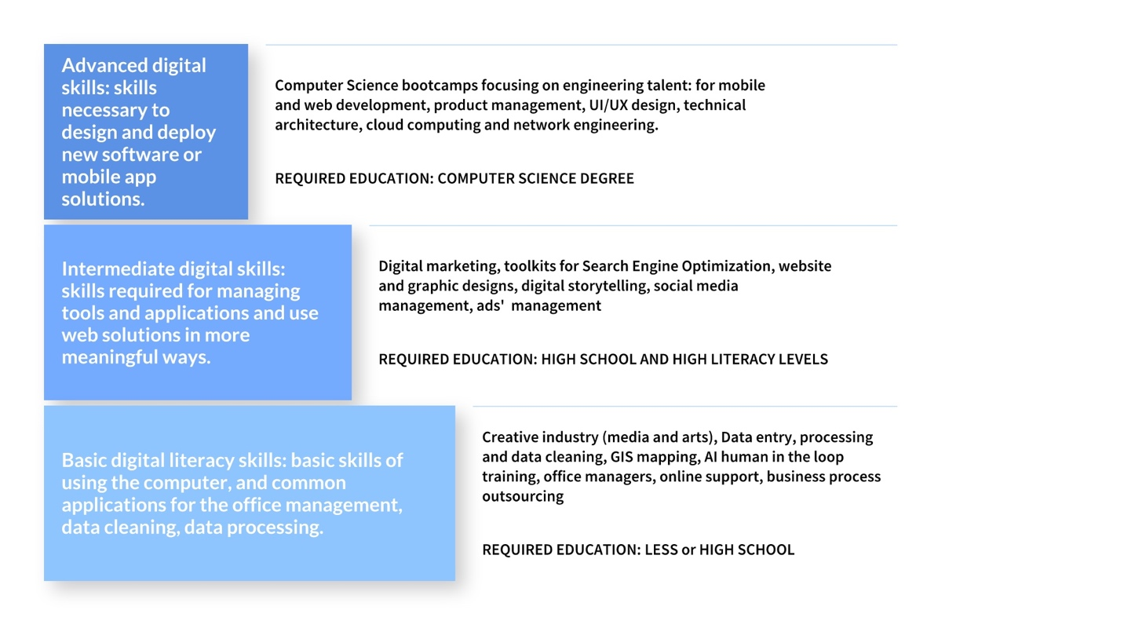
Schema 10. Digital training diversification
In addition to core digital and technology skills, soft skills will be incorporated in the training based on the selected career expectations of trainees.
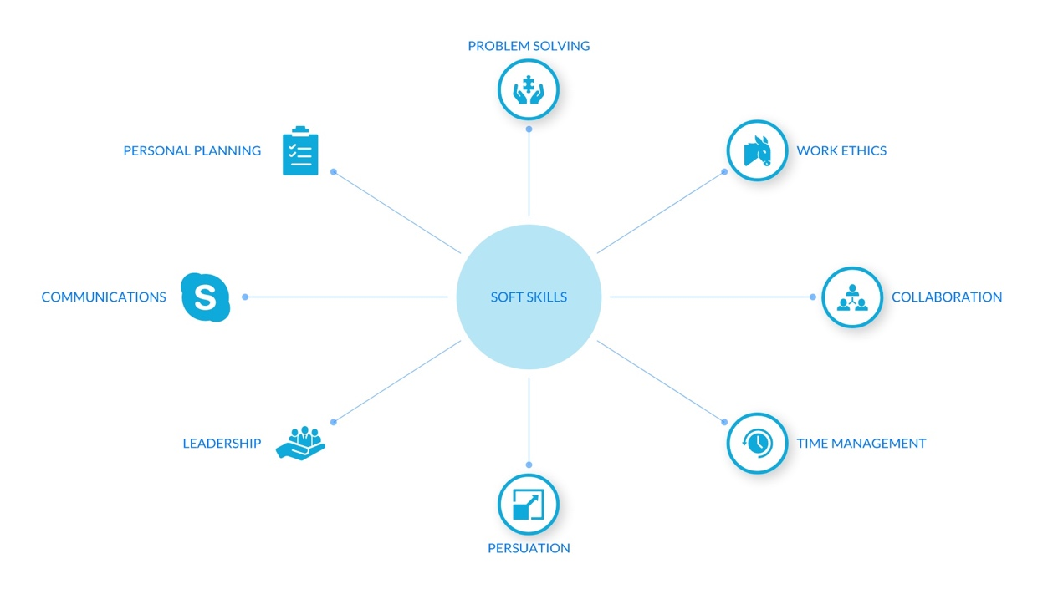
Schema 11. Soft skills training to prepare youth for waged employment and/or entrepreneurship
Output 1.4: National capacity building for implementation. Technical knowledge of the Government and local technology and innovation hubs is enhanced to institutionalize tools and models as formal TVET for digital economy.
The planned activities include:
- Capacity-building of government staff and local tech hubs (includes on-job training, study tours to learn from other countries/organizations)
- Trainer of trainees (TOTs) model to local technology and innovation hubs who will take over the training and skills development design in a sustainable manner.
Strategic outcome #2: Strengthened mechanisms, partnerships and platforms for employment and livelihood & job creation in the digital market (demand-side component)
Output 2.1: Market Demand Assessment. Private sector market demand mapping for digital skills at national, regional and global levels. Specific analysis to understand the gender dynamics within the Somali digital labour market.
The planned activities include:
- Assess market demand for digital skills at the national level through private sector mapping & survey (banking, telecom, media, energy and manufacturing sectors).
- Assess the hiring practices, data and processes in place for companies in Somalia to recruit digital talent, and understand the potential for transparent and equal hiring models
- Assess market demand tech skills and gaps at regional and global levels.
- Conduct context-specific analysis to understand the gender dynamics within the digital labour market- find gender roles, relations, constraints, and opportunities, and align all design decisions with those findings
Output 2.2: Employability and job placement. Mechanisms to connect graduates to digital jobs through internship or capstone placements, talent festivals, demo days, access to platforms for freelancing, and microwork.
The main activities include:
- Design partnership programme for employers with corporate private sector companies including at national level through unions, chamber of commerce, as well as diaspora-led, regional and international.
- Developing and integrating into the training project-based components of training and immediate job placement through internship and capstones for beneficiaries.
- Mapping SMEs in retail, construction, and transport sectors with an emerging interest in digitalization of business processes through mobile app development, web design, and interest in expanding digital marketing strategies.
- Building a strong alumni network through national tech community, demo days and job fairs, expertise sharing and continuous learning through invitation to workshops.
Output 2.3: Digital Economy Platform. A data-driven platform for connecting real-time and forecast of demand-supply in the digital economy. The platform will connect the digital workforce with employers, aggregate job sites, supply digital skills training hubs and policy makers with data on supply-demand and allow for additional intelligence and analytics.
The planned activities include:
- Stakeholder consultation on the design and customizing the digital jobs platform using the experience of UNDP Bangladesh's National Intelligence for skills, Employment and Skills and Entrepreneurship (NISE2)
- Data mapping and busines process design including the connection of trainers (hubs and academia), employers, and policymakers
- Software localization, development and launch
- Formalizing the alumni and tech community engagement digitally through the platform
- Analytics and intelligence dashboard development and user-testing
- Deployment and hosting, capacity support of Ministry of Labour and Social Affairs to host and maintain the Digital Economy Platform.
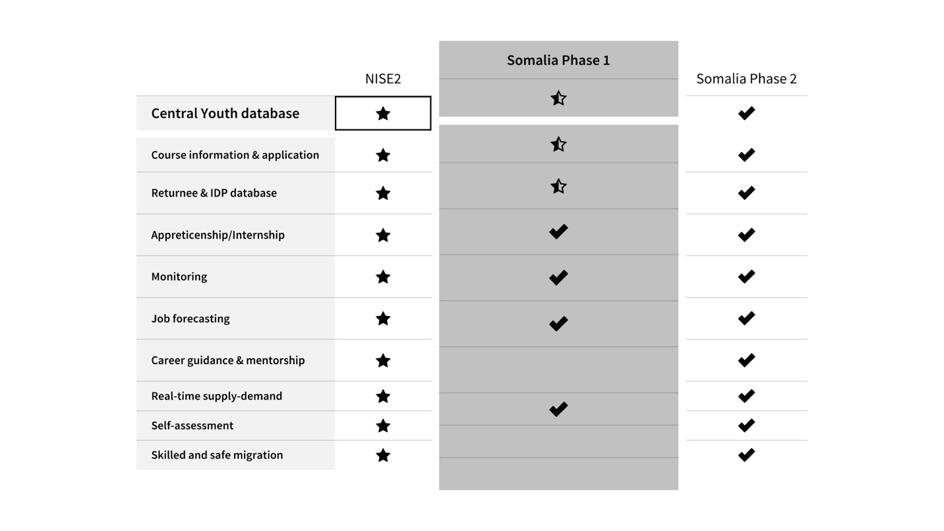
Schema 12. NISE2 UNDP Bangladesh adaptation and customization plan by modules and elements of the platform.
Output 2.4: Digital entrepreneurship. Design the process to support incubation and commercialization of tech enterprises as a sustainable employment path. This includes enterprise support for commercially viable products, access to finance, access to markets through partnerships with diaspora-led enterprises and global technology companies.
The planned activities include:
- Develop a local/global mentorship network, introduce business support for tech entrepreneurs to start the business
- Capacity development for tech hubs partners to fully support technology incubation, business model development, commercialization, and partner or market access support to tech entrepreneurs.
- Provide seed funding through access to finance i.e., Institutional in partnerships with banks, or crowdfunding
- Provide the ease of doing business for the incubates through policy influence over registration and incorporation, tax setup).
Strategic outcome #3: Improved policy & institutional frameworks to support digital economy (systemic and institutional change)
Output 3.1: Enabling environment. Strategies, policies, quality assurance frameworks and business regulations related to digital economy are in place.
The planned activities include:
- Provide suggestions to policies, processes to ensure high employability in the digital economy, including freelancing (tax restrictions, national IDs for IDPs/Returnees, access to banking) and digital entrepreneurship (registration, incorporation, tax setup).
- Develop minimum standard and framework for running digital skills training to turn into a national digital skills TVET model.
- Promote young men and women early-age exposure to ICTs including teach coding, two-week “Girls who Code” programs held at local schools and universities to gradually introduce project-based learning.
- Organize engagement forums to promote ‘tech for development’ ideas among youth.
Output 3.2: Output 3.2: Enhanced capacity & infrastructure of the National Technology & Telecommunication institute as centre of excellence for tech skills development
The planned activities include:
- Develop medium and longer-time Strategic plan for the institute,
- Staffing and technical expertise to support operationalization of the institute
- Establish operating facilities for the institute including digital infrastructure
Output 3.3 South-south cooperation. Partnerships, and processes are in place for cross-border employment: certifications, online platforms, software development agencies.
The planned activities include:
- Establish formalized process and partnerships with online platforms for freelancing.
- Establish formalized service agreements between local technology and innovation hubs and global software development agencies, microwork providers or academic institutions.
- Establish partnership between Institute of Information and Technology Somalia and ITI Egypt, and other exchange programmes.

Pre-launch activities/ongoing activities

Activity | Status
Conducting the programme baseline data collection to inform the design of the scale-up | Ongoing
Consultation processes, involving Government, Somali technology and innovation hubs to formulate digital economy priorities | Complete
Broader analysis of the digital economy ecosystem to better understand the roles and processes of digital economy at national, regional and global levels | Complete
Studying regional and global best-practice models of digital skills training and livelihood creation in post- conflict settings | Complete
Institutional readiness: mapping & capacity assessment technology and innovation hubs | Ongoing
Assess market demand for digital skills at the national level through private sector mapping & survey (banking, telecom, media, energy and manufacturing sectors). | Started
Assess the hiring practices, data and processes in place for companies in Somalia to recruit digital talent, and understand the potential for transparent and equal hiring models | Started
Assess market demand tech skills and gaps at regional and global levels. | Started
Table 3 Future Ready Scale-up prelaunch research activities

Partnerships and Ecosystem Engagement
Continuous ecosystem engagement and capacity building is required for gradual phase out of the scale programme into institutionalized self-sustained process, TVET model, and platform for Digital Economy.
In particular:
- Design and implementation of digital skills development training will be hosted and administered by local technology and innovation hubs.
- Partnerships with national private sector as hiring companies administered by local technology and innovation hubs.
- The data-driven platform for digital economy to become an online community for connecting graduates, hiring companies, and the Government.
- Partnerships with national and international financing institutions and programmes for seed funding and access to finance for digital enterprises.
- Global partnerships with online skills training providers, certification programmes, infrastructure: Flatiron school, Udacity, Amazon Web Services, Google, and software development agencies and platforms to ensure pathways for international employment of engineering talent, such as Andela, Upwork.
- The Federal Ministry of Communication and Technology (including the affiliated Institute of Technology and Telecommunication) and Ministry of Social Affairs and Labour will gradually become hosts of Future Ready scale up, promoting digital economy.
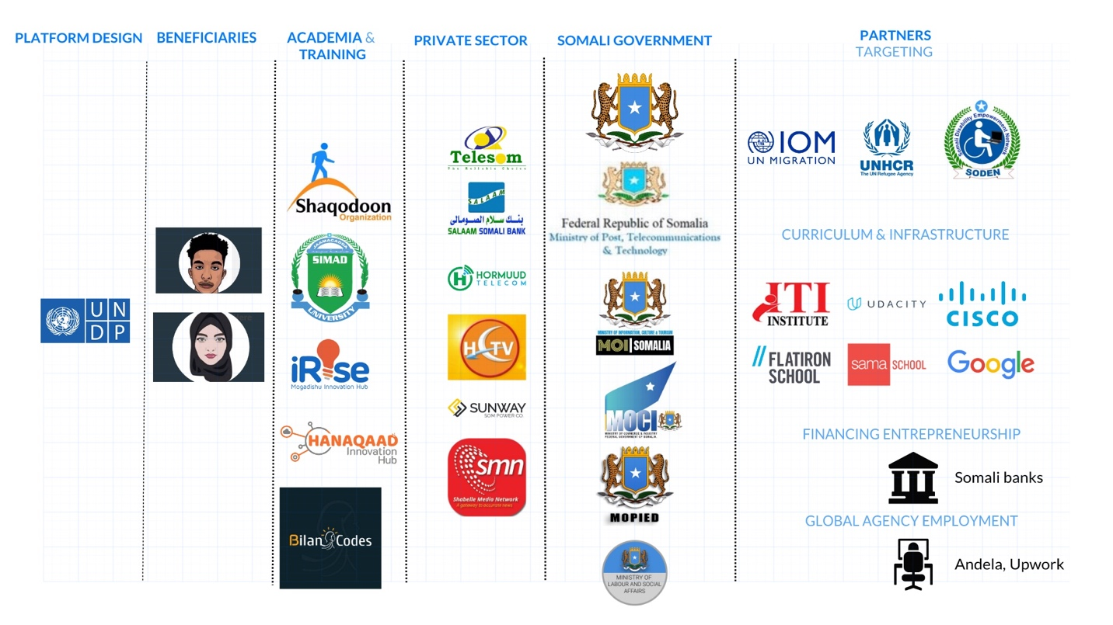
Schema 13. Future Ready Scale-up ecosystem mapping by functional roles

Targeted beneficiaries
There is significant ethnographic diversity in Somalia as a result of various socio-economic groups, migration processes and widening urban/rural divide, which affects access to education, and other basic services. The unemployment and education level disproportionally affect Somali women, as gender biases on the role of the women at home has excluded young women from formal employment. There are proportionally more women dropouts from school, married out early and/or allowing male siblings to study in case of limited economic opportunities for families. It leads to a high school and university dropout rate for women. Other groups are challenged by family economic needs, resulting in many youths engaged in the informal economy with poor job security.
The promise behind the digital economy is to bring clear professional pathways to different vulnerable groups, accommodating every individual group challenge on the way to decent work.
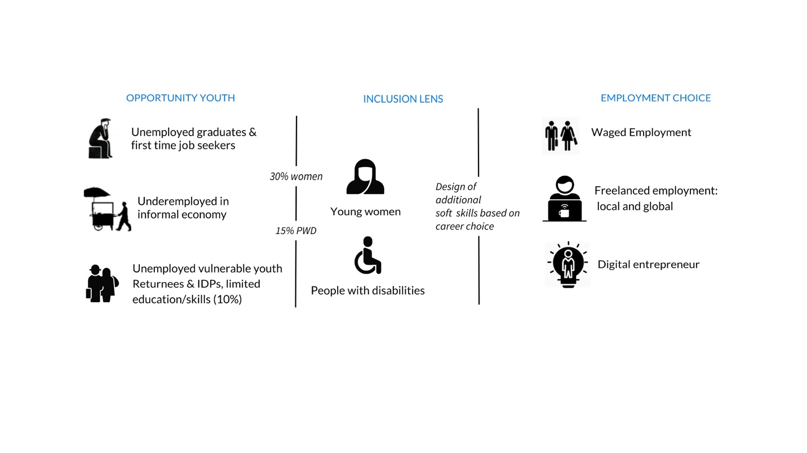
Schema 14. Targeting strategy for Future Ready Scale-up
The scale up programme targets the opportunity youth: aged 15 to 35. In particular,
- University graduates in computer science or related fields that are first time job seekers or first-time entrepreneurs who lacks practical skills
- Youth with high school education transitioning out from informal to formal economy with the interest in digital economy
- Vulnerable groups such as returnees, IDPs, people with disabilities with basic literacy skills

Geographic scope/ target locations
The pilot phase of the project was implemented in two main urban locations(Mogadishu and Hargeisa) that had good internet penetration and infrastructure. The Scale up programme will include Garowe, in addition to Mogadishu and Hargeisa.

Risks, Assumptions and mitigation strategies
Political and Security Complexity: The security situation is assessed in feasibility of the project implementation. Somalia may experience security deterioration in project locations, political risks associated to elections and politicization of project funds.
The programme is embedding in its design tools and activities that will contribute to the mitigation of these risks. The programme will leverage networks and area-based approaches to work on the mitigation of the social-economic impact of the pandemic and it will equally engage with rule of law and security actors on issues pertaining legal redress, and a careful security approach to the target locations of the project. Issues relates to the risk of politicization of funds will be dealt with by planning over a multi-year timespan, and through clear and transparent communication on budget allocations in relation to the achievement of the project objectives. To conclude on contextual risks, in lack of a formal system to regulate the financial sector, best available standards and safeguards will be used, and these include mobile transfers, biometric data, and monitoring payments.
Digital divide: The Internet penetration in Somalia stood at 11.9 % in 2020. In addition, there are high gaps between demographics and region that have access to modem information and communication technology – young people being more tech savvy, urban vs rural, IDPs and returnees most vulnerable in accessing digital tools and skills.
The program integrated both short term and longer time mechanisms to mitigate this risk including putting women IDPs and returnees as core target groups by providing digital literacy skills as well supporting government expand access to internet, information technologies, digital infrastructure as well inclusion of digital literacy in the education system, with particularly focus on the most vulnerable members of the community.
Insufficient access to finance: While Somalia’s economic and financial sectors is recovering from prolonger civil war, the country is still in international financial restrictions making it harder to send money from abroad directly to local banks. This could be a challenge to Somali freelancers who would participate in regional and global talent hire, as well as cross-border employment. Another potential risk is access to finance for start-ups and digital entrepreneurs. Graduates who develop commercially viable and tested digital solutions as tech start-ups to fill the market gaps can be supported with access to finance via alternative financing mechanisms like crowdfunding, diaspora-led seed rounds.
Regulatory environment: Somalia, as of 2020, is at 190 out of 190 counties in Doing Business Index. Current regulatory restrictions and embargoes may significantly challenge the reputation in setting up international partnerships and recruitment for graduates. Additionally, tax regulations and absence of tax treaties for hiring with countries, may result in diminished interest in talent hire from Somalia. UNDP will actively seek to address the risk of poor regulatory environment for global digital economy through streamlining partnership with freelancing platforms, global software development agencies, and white labelling the setup in the international arena.

South-South and triangular cooperation (SSC/TrC)
The programme will build on the initial discussions between the National Technology & Telecommunication Institute, Somalia and Egypt’s Information Technology Institute (ITI) and the establishment of official arrangements need to be finalized. ITI Egypt, the leading tech hub in Africa agreed to support National Technology Institute in ICT research and training, including scholarship to Somali youth.
In addition, the programme will also explore experience from UNDP Bangladesh's National Intelligence for skills, Employment and Skills and Entrepreneurship (NISE2). The platform connects digital talent/ workforce with employers, aggregate job sites, TVET and policy makers using big data analytics.
Wherever applicable, the project will promote joint learning between Somalia, regional and global countries engaged in digital economy programmes.

Knowledge, Communications and Visibility
We will produce knowledge materials formulating our approaches, to create visibility for lessons learned generated by the programme.
A communication strategy will be prepared to ensure systematic communication to key stakeholders at different levels in Somalia, special focus will be given to digital communication.
As part of the governance structure, the partners will report upon implementation of the communication and visibility plan regularly, a dedicated digital communication specialist will be recruited. Donor visibility will be ensured at trainings, public events, coordination meetings and national advocacy activities. This will include any of the Donors’ policy related to the initiatives connected to this program. Materials to publicise the partnership will include joint press releases (highlighting key milestones in the project) along with photographs, human interest stories and video reports featuring beneficiaries (that will be uploaded to the UN country office pages and global websites, for example) to demonstrate how the interventions have supported digital economy in Somalia.
All printed material, including training materials, will display donor logos in line with visibility requirements. The UN and partners will ensure that all communication about this program including press releases, videos and calendars, advocacy and communication materials are disseminated amongst beneficiaries and external stakeholders mention the donor support.

Sustainability
Institutional Sustainability. The programme approaches institutional sustainability as a fundamental principle. There is a long-term plan to phase out administration and hosting of the programme to the Government and local technology and innovation hubs. For the period of programme implementation UNDP will be building and strengthening national capacity to maintain and grow digital economy.
Financial Sustainability: The programme will support local technology and innovation hubs for the duration of the programme implementation period. The financial stability of the programme will be explored through the models of monetization:
- Hiring companies’ (employers) contributions.
- Software development services to companies.
- Graduates’ financial contribution as a payment for training.
For remaining elements, UNDP will advocate that the Somali Government will allocate the annual budget for continuous support and expansion of the Digital Economy programming.

Results Framework

-Intended outcome as stated in the UNSDCF (2021-2025): Outcome 3.3: An integrated national programme for human capital development is established, increasing access to market-based skills for all – including the most marginalized and vulnerable groups – and safeguarding their rights
-Intended outcome as stated in UNDP CPD (2021-2025): Outcome 3: Sustainable Natural Resource Management for Inclusive economic growth
-Contributing to UNDP’s Jobs and Livelihood Pledge (Global Refugee Forum 2019)
Outcome indicator as stated in the CPD: Economic governance institutions are strengthened, and an enabling environment established for inclusive, sustainable and broad-based economic growth driven by the emerging small and medium enterprise (SME) sector.
CPD output: Enhanced access of SMEs to business development services (BDS)  Indicator: Number of enterprises receiving support disaggregated by sector  Baseline: 1 (2020)  Target: 10 per state  Source: Third-party monitoring  Frequency: Annual  Indicator: Number of women, youth and persons with disabilities–owned enterprises capacitated  Baseline: 0 (2020)  Target: 10 per category  Source: Third-party monitoring  Frequency: Annual | CPD output: Expedited digital economy application for target groups  Indicator: Increase of service sector (as proxy for a digital economy) contribution to GDP  Baseline: 0  Target: 2% annual increase  Source: Third -party monitoring  Frequency: Annual  Indicator: Number of youths trained on digital literacy  Baseline: 100(2020)  Target: 10,000  Source: Project reports  Frequency: Annual  Indicator: Number of private sector entities employing youths  Baseline: No data (2020)  Target: Additional 6  Source: Third-party monitoring  Frequency: Annual |  | CPD output: Durable Solutions for IDPs are implemented for stabilization, livelihoods and peace  Indicator: Number of IDPs benefitting from livelihoods initiatives  Baseline: 23,557 (2020)  Target: 250,000  Source: Third-party monitoring  Frequency: Annual
EXPECTED OUTPUTS | OUTPUT INDICATORS | DATA SOURCE | BASELINE |  | TARGET  (by frequency of data collection) |  |  |  |  | DATA COLLECTION  METHODS AND RISKS
 |  |  | 2019 | 2020 | 2021 | 2022 | 2023 | 2024 | FINAL
Strategic outcome 1: Enhanced capacities of the Government and local technology and innovation hubs to design and implement inclusive, digital skills development for market-driven digital jobs (supply-side component)
Output 1.1: Ecosystem readiness. Understanding of the national digital economy ecosystem, related processes and data flows, capacity assessment of local technology and innovation hubs. | # assessments, studies and mapping conducted | Project report, UNDP COs reports | 0 | 0 | 2 | 1 |  |  | 3 | Copies of assessments, studies and mapping reports
Output 1.2: Targeting. Mechanisms and incentives set for recruiting beneficiaries, including targeting vulnerable groups of people with disabilities, IDPs and returnees. | Proportion of direct beneficiaries of training, digital entrepreneurship and employment placement are:  - Women  - People with disabilities  - IDPs and returnees | Project report, UNDP COs reports | 15%  N/A  N/A | 15%  10%  N/A | 20%  10%  10% | 25%  15%  10% | 30%  15%  10% | 30%  15%  10% | 30%  15%  10% | Outreach and selection list,
Output 1.3: Training and curriculum design. Digital skills trainings are organized to produce certified digital talent, having options for different employment paths. | # Course curriculums designed, tested and licensed through partnerships to local technology and innovation hubs. | Project report, UNDP COs reports | 1 | 2 | 3 | 2 | 0 | 0 | 7 | Approved curriculum
 | Number of beneficiaries, disaggregated by sex, age & location) provided skills development training in the following categories:  - Basic (digital literary)  - Intermediate  - Advanced | Project report, UNDP COs reports | 0  1 | 0  0 | 100  100  100 | 600  600  300 | 400  400  300 | 400  400  300 | 1,500  1,500  1,000  4,000 | List of project trainees & training certificates  Course materials
Output 1.4: National capacity building for implementation. Technical knowledge of the Government and local technology and innovation hubs is enhanced to institutionalize tools and models as formal TVET for digital economy. | # of TOT hired  # TOT trainings executed | Project report, UNDP COs reports | 0  1 | 0  0 | 9  3 | 6  3 | 3  2 | 0  0 | 18  8 | List of project trainees & training certificates  TOT material
Strategic outcome 2: Increased demand and transparency in employment by private sector in the digital economy through strengthened mechanisms, partnerships and platforms (demand-side component)
Output 2.1: Market demand Assessment. Private sector market demand mapping for digital skills at national, regional and global levels. Specific analysis to understand the gender dynamics within the Somali digital labour market. | # of private sector companies (both large and SMEs) engaged in the market assessment | Project report, UNDP COs reports | 0 | 0 | 10 | 0 | 15 | 0 | 25 | Market assessment report
Output 2.2: Employability and job placement programmes. Mechanisms to connect graduates to digital jobs through internship or capstone placements, talent festivals, demo days, access to platforms for freelancing, and microwork. | # of Somali private sector hiring partners to programme  # of SMEs benefiting through digital products (paid by SMEs or adjacent other programmes for SMEs)  # of job placements facilitated | Project report, UNDP COs reports | 0  0  0 | 0  0  0 | 10  20  100 | 40  60  300 | 80  100  500 | 100  220  700 | 100  400  1600 | List of private sectors hiring partner,  SMES getting business development services  List of graduates starting jobs
Output 2.3: Digital Economy Platform. A data-driven platform for connecting real-time and forecast of demand-supply in the digital economy. The platform will connect the digital workforce with employers, aggregate job sites, supply digital skills training hubs and policy makers with data on supply-demand and allow for additional intelligence and analytics | # graduates actively engaging in Digital Economy through Platform  # private sector companies actively engaging in Digital Economy through Platform  # of internships, and jobs placements through the real-time job aggregators | Project report, UNDP COs reports | 0  0  0 | 0  0  0 | 300  10  50 | 600  20  150 | 1000  40  250 | 1400  80  350 | 3300  150  800 | Data driven-digital platform
Output 2.4: Digital entrepreneurship. Design the process to support incubation and commercialization of tech enterprises as a sustainable employment path. This includes enterprise support for commercially viable products, access to finance, access to markets through partnerships with diaspora-led enterprises and global technology companies. | # of tech start-ups incubated into a market-ready enterprise | Project report, UNDP COs reports | 0 | 0 | 10 | 10 | 10 | 10 | 40 | List of new SMEs established and supported;
Strategic outcome 3: Improved policy & institutional frameworks to support digital economy (systemic and institutional change)
Output 3.1 Enabling environment. Strategies, policies, quality assurance frameworks and business regulations related to digital economy are in place. | #Strategies, quality assurance and certifications are formalized  # Organize engagement forums to promote ‘tech for development’ ideas among youth | Project report, UNDP COs reports | 0  0 | 0  0 | 1  1 | 0  1 | 0  1 | 1  1 | 2  4 | Copies of polices, strategies, certification & quality assurance framework
Output 3.2: Enhanced capacity & infrastructure of the National Technology & Telecommunication institute as centre of excellence for tech skills development | # Develop medium and longer-time Strategic plan for the institute,  #Staffing and technical expertise to support operationalization of the institute | Project report, UNDP COs reports | 0  0 | 0  0 | 0  2 | 1  2 | 0  3 | 0  3 | 1  8 | Copy of the strategic plan  Copy of staff contracts
Output 3.3: South-south cooperation. Partnerships, and processes are in place for cross-border employment: certifications, online platforms, software development agencies. | # of partnership formalized  # of learning study trips | Project report, UNDP COs reports | 0  1 | 0  0 | 1  1 | 1  1 | 1  1 | 1 | 3  4 | Copy of partnership agreements
Table 4 Logframe of outcomes, outputs, key activities and indicators

Monitoring and Evaluation
In accordance with UNDP’s programming policies and procedures, the project will be monitored through the following monitoring and evaluation plans:
M&E and Reporting Overview
Monitoring Activity | Purpose | Frequency | Expected Action
Baseline assessment | Baseline information will be collected which will be measured against over the course of the project | Once, within the first six months. | Baseline report will be available
Track results progress | Progress data against the results indicators in the RRF will be collected and analysed to assess the progress of the project in achieving the agreed outputs. Results related to perception will be measured during midterm and final evaluation. | Quarterly, or in the frequency required for each indicator. | Slower than expected progress will be addressed by project management.
Monitor and Manage Risk | Identify specific risks that may threaten achievement of intended results. Identify and monitor risk management actions using a risk log. | Quarterly | Risks are identified by project management and actions are taken to manage risk. The risk log is actively maintained to keep track of identified risks and actions taken.
Learn | Knowledge, good practices and lessons will be captured regularly, as well as actively sourced from other projects and partners and integrated back into the project. This learning will be shared with the available knowledge management and sharing platforms, | At least annually | Relevant lessons are captured by the project team and used to inform management decisions.
Annual Project Quality Assurance | The quality of the project will be assessed against UN’s quality standards to identify project strengths and weaknesses and to inform management decision making to improve the project. | Annually | Areas of strength and weakness will be reviewed by project management and used to inform decisions to improve project performance.
Review and Make Course Corrections | Internal review of data and evidence from all monitoring actions to inform decision making. | At least annually | Performance data, risks, lessons and quality will be discussed by the project board and used to make course corrections.
Project Report | A progress report will be presented to the Project Board and key stakeholders, consisting of progress data showing the results achieved against pre-defined annual targets at the output level, the annual project quality rating summary, an updated risk log with mitigation measures, and any evaluation or review reports prepared over the period. | Annually, and at the end of the project (final report)
Project Review (Project Board) | The Project Board will hold regular project reviews to assess the performance of the project and review the Multi-Year Work Plan to ensure realistic budgeting over the life of the project. In the project’s final year, the Project Board shall hold an end-of project review to capture lessons learned and discuss opportunities for scaling up and to socialize project results and lessons learned with relevant audiences. | Annually | Any quality concerns or slower than expected progress should be discussed by the project board and management actions agreed to address the issues identified.
Mid-Term Evaluation |  | End of Year 2 | FGS partners, FSM anti-corruption units, civil society reps, private sector reps, development partners,
Final Evaluation |  | End of Year 4 | FGS partners, FSM anti-corruption units, civil society reps, private sector reps, development partners
Table 5. Monitoring and Evaluation design for Future Ready Scale-up

Governance and Management Arrangements

Governance structure
The programme will be governed by an executive board whose primary role is to make strategic decisions related to the program planning and implementation, including approving the yearly workplan and budget allocation.
The executive board of this programmme will be chaired by the Resident Representative of UNDP Somalia and by H.E. the Minister of Communication and Technology, Federal government of Somalia. Members of the executive board are Ministry of Social Affairs and labour, Ministries of Technology and Telecommunication in targeted Federal Member States and Representative from donor countries/organizations. Teams supporting the members may participate in the capacity of observers with the sole purpose of facilitating the participation of the members.
Specific functions of the board will include:
- Managing the strategic programmatic risk, and mitigating related contextual, political and strategic risks,
- Makes decisions on fund reallocation of activities based on the performance and implementation rate of the various partners.
- The board may appraise and decide on the inclusion of new members – whether they be government entities, contributing donors or Implementing partners in the project document.
The board can hold ad-hoc meetings when requested by a majority of partners and meets at least every six months. The board meeting gathers in Mogadishu and facilitates online connection with other locations to ensure full participation of its members. Secretariat functions of the joint steering committee meetings will be executed by UNDP and these include the preparation of the meetings, note taking and circulation of relevant materials ahead of the sessions. In particular cases the Board will adopt simplified procedures for decision making to comply with necessities driven by the content.
Government Authority | Role | Implementation and alignment with national priorities
Ministry of Communication and Technology, Federal Government of Somalia | Executive Board Membership | Core partner, Program Focal Point and coordination,
Ministry of Social Affairs and Labour, Federal Government of Somalia | Executive Board Membership | Lead partner in the employment creation component of the program
Federal Member State Ministry that has mandate in Communication and Technology | Executive Board Membership | Oversight on project implementation
Federal Member State Ministry that has mandate in Communication and Technology | Executive Board Membership | Oversight on project implementation
Federal Member State Ministry that has mandate in Communication and Technology | Executive Board Membership | Oversight on project implementation
Table 6 Ministries representing Somali Government in the Executive Board

Management ARRANGEMENTS (Adaptive and agile approach)
The Program will be managed by the Economic Recovery and Institutional Development (ERID) portfolio within UNDP Somalia Country Office.
UNDP will provide project management and oversight through Direct Implementation Modality (DIM) modality. Support from the regional hub for technical expertise will be utilized to ensure high quality result are attained.
There will be a dedicated team to handle the project management arrangements in accordance with the standard UNDP procedures. A project management board will be established and chaired by UNDP with membership from other key stakeholders for strategic guidance and oversight of the project.
The structure below shows the project organization and management arrangements.
Executive Board (Governance Mechanism)

Technical Specialist/Experts
(Consultancy type of arrangement)
Digital Communication officer (full-time)
Leading on digital communication, reporting and visibility
Project Assurance:

CO Program Oversight and Quality Assurance (POQA)unit
Project Manager (full time)

For day-to-day management, program delivery & observer role in the Executive board
Project Support
Senior project assistant, (full time) working closely with UNDP portfolio and operation
Senior Beneficiary:
Government of Somalia
Executive:

UNDP
Senior Supplier:

UNDP SOMALI (ERID Portfolio)

Schema 15. Management structure
In addition, the 2020 Covid-19 pandemic has demonstrated the importance of agile management of programmes that may also be subject to human made and natural disasters. Being cognizant of changing context and needs in Somalia, the program will ensure adaptive management through flexibility and responsiveness at the centre of the programme design.
A strong emphasis on adaptive learning will ensure that the Programme capitalizes on the significant added value of each partner.

Multi-Year Work Plan (Tentative)
EXPECTED OUTPUTS | PLANNED ACTIVITIES | Planned Budget by Year |  |  |  | PLANNED BUDGET
 |  | Y1 | Y2 | Y3 | Y4
 |  |  |  |  |  | Amount
Output 1.1: Ecosystem readiness. Understanding of the national digital economy ecosystem, related processes and data flows, capacity assessment of local technology and innovation hubs. | -Conducting programme baseline data collection to inform the design of the scale-up | $40,000 |  |  |  | $40,000
 | -Digital economy ecosystem mapping including mapping of digital skills demand, digital job typology | $40,000 |  |  |  | $40,000
 | -Institutional readiness: mapping & capacity assessment of government and local technology innovation hubs | $40,000 |  |  |  | $40,000
Output 1.2: Targeting. Mechanisms and incentives set for recruiting beneficiaries, including targeting vulnerable groups of people with disabilities, IDPs and returnees. | -Conducting outreach and engagement (both online and offline) activities to attract target groups as beneficiaries. | $50,000 |  |  |  | $50,000
 | -Registering, ensuring key eligibility criteria of the programme’s target groups/ beneficiaries. | $20,000 | $10,000 | $10,000 | $10,000 | $50,000
 | -Profiling the youth beneficiaries, and collecting baseline data on employment, potential career paths. | $10,000 | $10,000 | $10,000 | $10,000 | $40,000
 | -Putting in place the tight monitoring system to evaluate performance and follow up | $40,000 |  |  |  | $40,000
 | Incentives to attract the most vulnerable i.e., IDPs, People with disabilities, and maintain the high women participation. (including transport costs etc | $5,000 | $5,000 | $5,000 | $5,000 | $20,000
Output 1.3: Training and curriculum design. Digital skills trainings are organized to produce certified digital talent, having options for different employment paths. | -Design bootcamp curriculum including partnerships, or formalized certification programmes (eg Udacity, Flatiron school) | $15,000 |  | $15,000 |  | $30,000
 | -Conducting bootcamp trainings in 3 target location (min 2 cohorts per year per location. Total of 4,000 | $200,000 | $200,000 | $200,000 | $200,000 | $800,000
Output 1.4: National capacity building for implementation. Technical knowledge of the Government and local technology and innovation hubs is enhanced to institutionalize tools and models as formal TVET for digital economy. | -capacity-building of core government partners including hiring national experts to be attached to the ministries, equipment’s etc | $90,000 | $90,000 | $90,000 | $90,000 | $360,000
 | -Trainer of trainees (TOTs) model to local technology and innovation hubs who will take over the training and skills development design in a sustainable manner. | $10,000 | $10,000 | $10,000 | $10,000 | $40,000
Sub-Total for Output 1 |  | $560,000 | $325,000 | $340,000 | $325,000 | $1,550,000
Output 2.1: Market demand Assessment. Private sector market demand mapping for digital skills at national, regional and global levels. Specific analysis to understand the gender dynamics within the Somali digital labour market. | -Assess market demand for digital skills at the national level through private sector mapping & survey (banking, telecom, media, energy and manufacturing sectors) including private sector hiring practices, data and processes | $20,000 |  |  |  | $20,000
 | -Conduct context-specific analysis to understand the gender dynamics within the digital labour market- find gender roles, relations, constraints, and opportunities, and align all design decisions with those finding | $20,000 |  |  |  | $20,000
Output 2.2: Employability and job placement programmes. Mechanisms to connect graduates to digital jobs through internship or capstone placements, talent festivals, demo days, access to platforms for freelancing, and microwork. | -Partnership programme for employers with corporate private sector companies | $10,000 |  |  |  | $10,000
 | -Immediate job placement through internship, capstones or full employment for beneficiaries. | $50,000 | $50,000 | $50,000 | $50,000 | $200,000
 | -Mapping SMEs in retail, construction, and transport sectors with an emerging interest in digitalization of business processes | $10,000 |  |  |  | 10,000
 | -Organizing demo days and job fairs that bring together graduated tech talents and employers | $15,000 | $15,000 | $15,000 | $15,000 | $60,000
Output 2.3: Digital Economy Platform. A data-driven platform for connecting real-time and forecast of demand-supply in the digital economy. The platform will connect the digital workforce with employers, aggregate job sites, supply digital skills training hubs and policy makers with data on supply-demand and allow for additional intelligence and analytics | -Stakeholder consultation on the design and customizing the platform | $20,000 |  |  |  | $20,000
 | -Data mapping and busines process design including the connection of trainers (hubs and academia), employers, and policymakers | $20,000 |  |  |  | $20,000
 | -Software localization, development and launch | $200,000 |  |  |  | $200,000
 | -Deployment and hosting, capacity support for Ministry of Social Affairs and Labor. | $40,000 | $40,000 |  |  | $80,000
Output 2.4: Digital entrepreneurship & enterprise. Design the process to support incubation and commercialization of tech enterprises as a sustainable employment path. This includes enterprise support for commercially viable products, access to finance, access to markets through partnerships with diaspora-led enterprises and global technology companies. | -Develop a local/global mentorship network, introduce business support for tech entrepreneurs to start the business | $40,000 | $40,000 | $40,000 | $40,000 | $160,000
 | -Capacity development for tech hubs partners to fully support technology incubation, business model development, commercialization, and partner or market access support to tech entrepreneurs. | $50,000 | $50,000 | $50,000 | $50,000 | $200,000
 | -Provide seed funding through crowdfunding campaigns (Campaign management costs) | $10,000 | $10,000 | $10,000 | $10,000 | $40,000
Sub-Total for Output 2 |  | 505,000 | $205,000 | $165,000 | $165,000 | $1,020,000
Output 3.1 Enabling environment. Strategies, policies, quality assurance frameworks and business regulations related to digital economy are in place. | -Develop minimum standard and framework for running digital skills training to turn into a national digital skills TVET model. | $20,000 |  |  |  | $20,000
 | -Promote young men and women early-age exposure to ICTs including teach coding, two-week “Girls who Code” programs held at local schools and universities to gradually introduce project-based learning. | $40,000 | $40,000 | $40,000 | $40,000 | $160,000
 | -Organize engagement forums to promote ‘tech for development’ ideas among youth. | $40,000 | $40,000 | $40,000 | $40,000 | $160,000
Output 3.2: Enhanced capacity & infrastructure of the National Technology & Telecommunication institute as centre of excellence for tech skills development | -Establish national technology & Telecommunication (including mobile labs) who will gradually take over digital skills development programme | 500,,000 | 500,000 | 500,000 | 500,000 | $2,000,000
 | -Establish partnership between Institute of Information and Technology Somalia and ITI Egypt, and other exchange programmes. | $10,000 |  |  |  | $10,000
 | -Support Ministry of Labour and Social Affairs to host and maintain the Digital Economy Platform. | $5,000 | $5,000 | $5,000 | $5,000 | $20,000
Output 3.3: South-south cooperation. Partnerships, and processes are in place for cross-border employment: certifications, online platforms, software development agencies. | -South-South Cooperation and learning tours of government and local tech hubs | $50,000 | $50,000 | $50,000 | $50,000 | $200,000
 | -Establish formalized process and partnerships with online platforms for freelancing. | $10,000 |  |  |  | $10,000
 | -Establish formalized service agreements between local technology and innovation hubs and global software development agencies, microwork providers or academic institutions. | $10,000 |  |  |  | $10,000
Sub-Total for Output 3 |  | $685,000 | $635,000 | $635,000 | $635,000 | $2,590,000
TOTAL OUTPUT 1-3 |  |  |  |  |  | $5,160,000
Output 4. Project Management | Project UN staff Salary (3 project staff) | $500,000 | $500,000 | $500,000 | $500,000
 | Training UN staff (monitoring missions) | $20,000 | $20,000 | $20,000 | $20,000
 | Training UN staff | $10,000 | $10,000 | $10,000 | $10,000
 | Communication | $15,000 | $15,000 | $15,000 | $15,000
 | Audit |  | $20,000 |  | $20,000
 | Quality Assurance | $20,000 | $20,000 | $20,000 | $20,000
 | Equipment UN staff | $20,000 | $20,000
 | Mid and End-term Evaluation |  | $50,000 |  | $50,000
 | Supplies | $10,000 | $10,000 | $10,000 | $10,000
TOTAL OUTPUT 4 |  | $395,000 | $465,000 | $375,000 | $425,000 | $1,660,000
TOTAL OUTPUT 1-4 |  |  |  |  |  | $6,820,000
DPC (8%) |  |  |  |  |  | $682,000
GRAND TOTAL |  |  |  |  |  | $7,502,000

Note: Adjust signatures as needed ² The Gender Marker measures how much a project invests in gender equality and women’s empowerment. Select one for each output: GEN3 (Gender equality as a principle objective); GEN2 (Gender equality as a significant objective); GEN1 (Limited contribution to gender equality); GEN0 (No contribution to gender quality)
https://www.weforum.org/reports/the-future-of-jobs-report-2020
https://unsdg.un.org/sites/default/files/2020-11/Somalia-UNSDCF-2021-2025.pdf
https://datareportal.com/reports/digital-2020-somalia
http://mop.gov.so/wp-content/uploads/2019/12/NDP-9-2020-2024.pdf
https://unsdg.un.org/sites/default/files/2020-11/Somalia-UNSDCF-2021-2025.pdf
https://pressroom.ifc.org/all/pages/PressDetail.aspx?ID=26072
https://mptt.gov.so/en/wp-content/uploads/2019/11/National-ICT-Policy-Strategy-2019-2024.pdf
https://unidosomalia.medium.com/unido-facilitates-credit-facility-for-small-and-medium-sized-enterprises-f5c823ba0860 & http://smefbds.com/our-services/
https://datacatalog.worldbank.org/dataset/somalia-informal-sector-business-survey-2019
https://www.weforum.org/agenda/2019/08/youngest-populations-africa/#:~:text=Niger%20is%20set%20to%20have%20the%20world's%20youngest%20population%20in,to%20nearly%20triple%20by%202050.
UNDP Country Programme Document for 2021-2025
United Nations Development Programme (2012). Somalia Human Development Report 2012: Empowering Youth for Peace and Development
https://www.iti.gov.eg/
UNDP 2020: Future Ready Pilot Assessment Report
UNDP Country Programme Document 2021-2025 cycle
http://mop.gov.so/wp-content/uploads/2019/12/NDP-9-2020-2024.pdf
https://somalia.unfpa.org/sites/default/files/pub-pdf/UNFPA%20Somalia%20National%20Youth%20Policy%20Eng%20fa.pdf
https://mptt.gov.so/en/wp-content/uploads/2019/11/National-ICT-Policy-Strategy-2019-2024.pdf
https://unsdg.un.org/sites/default/files/2020-11/Somalia-UNSDCF-2021-2025.pdf
https://www.undp.org/content/undp/en/home/librarypage/poverty-reduction/global-refugee-forum-2019--defining-undp-s-development-commitmen.html
https://sdgs.un.org/goals
https://unsdg.un.org/sites/default/files/2020-11/Somalia-UNSDCF-2021-2025.pdf
Detailed nature of the policies to be in place will be suggested upon consultations and further research, and implementation of the programming
So far, an initial assessment of the pilot initiative has been done. However, these were not sufficient to carry out baseline assessment for all indicators. In person data collection were severely limited by COVID 19.

